Estradiol promotes habituation learning via an unidentiﬁed target, bypassing the suppressive effects of established

Estrogen Receptors

## Andrew Hsiao !,1,2, Isabelle Darvaux-Hubert !,1, Dominique Hicks !,1,3, Emilie Joux 1,2, Sarah De Freitas 1,2, Emeline Dracos 1,2, Jeanne Lizé 1,2, Julien Perrichet1, Dominique Baas *,1, Owen Randlett *,1,@

1 Laboratoire MeLiS, Université Claude Bernard Lyon 1 - CNRS UMR5284 - Inserm U1314, Institut NeuroMyoGène, Faculté de Médecine et de Pharmacie, 8 avenue Rockefeller, 69008 Lyon, France

2 International Master in Life Sciences, Université Claude Bernard Lyon 1, France

3 Master of Biology Program, École normale supérieure de Lyon, France

!equal contribution

*equal contribution

@correspondence: [owen.randlett@univ-lyon1.fr](mailto:owen.randlett@univ-lyon1.fr), ORCID: [0000-0003-0181-5239](https://orcid.org/0000-0003-0181-5239)

**Abstract**

Habituating to the constant stimuli in the environment is a critical learning process conserved across species. We use a larval zebraﬁsh visual response to sudden darkness as a model for studying habituation learning, where zebraﬁsh reduce their responses to repeated stimulations. In this paradigm, treatment with estradiol strongly increases learning rate, resulting in more strongly suppressed responses. We used mutant lines for the Estrogen Receptors (*esr1*, *esr2a*, *esr2b*, *gper1*) in an attempt to identify the receptor(s) mediating these effects. These experiments failed to identify a necessary receptor (or combination of receptors). Surprisingly, *esr1*, *esr2a*, and *gper1* mutants showed weak but consistent increases in habituation, indicating these receptors suppress habituation learning. These experiments demonstrate that estradiol is a complex modulator of learning in our model, where the learning-promoting effects are mediated by an unidentiﬁed estradiol target, and the classical Estrogen Receptors act in competition to subtly suppress learning.

# Introduction

A primary function of the brain is to learn from experiences and adjust behavior in response. One aspect of learned behaviour involves sharpening attention and behavioural resources toward salient cues by ignoring irrelevant background stimuli. For instance, it may be critical to recognize the alarm calls of a nearby animal, whereas continually registering the steady hum from distant traﬃc is far less important. The capacity to reduce responses to repetitive, non-essential stimuli is known as habituation, which is considered the simplest form of learning and memory [1].

We study a paradigm for long-term habituation where larval zebraﬁsh reduce their responsiveness to sudden pulses of whole-ﬁeld darkness, or dark ﬂashes (DFs) [2, 3, 4]. We recently reported that multiple hor- monal signaling pathways show strong modulation of habituation learning performance, including melatonin,

progesterone, and estrogen [4]. The ability of these signaling pathways to modulate learning is consistent with previous results in other systems and paradigms [5, 6, 7, 8, 9, 10, 11], and may be an important mechanism to shift learning and memory performance or strategies based on biological rhythms or external ﬂuctuations like seasons, weather or the day/night cycle.

In this project we have focused on estrogen signaling. We identiﬁed multiple estradiol analogs which strongly increased habituation learning when bath applied at 5-10µM doses (ethinyl estradiol, estradiol valerate, and hexestrol, 4). 17β-estradiol (here referred to as estradiol) is the most potent and biologically active form of estrogen, and is used in a variety of clinical contexts including contraception, hormone replacement therapy, and feminizing hormone therapy [12, 13, 14].

Our discovery of a role for estradiol in promoting habituation learning is not surprising, as it has well doc- umented effects on other learning and memory processes [15]. This has been most extensively characterized in the hippocampus, where estradiol promotes behavioural performance and the cellular/circuit hallmarks of hippocampal plasticity, including Long-term potentiation (LTP) and modulation of dendritic spine density [16, 17, 18, 5]. While the role of estradiol in habituation is less well explored, it has previously been shown to increase memory retention for olfactory habituation in mice [7], indicating it plays conserved roles in plasticity regulation across paradigms.

Estradiol signals via two established classes of Estrogen Receptors (ERs): the ligand-activated transcription factors ERα, and ERβ, and the seven-transmembrane G-protein coupled receptor Gper1. ERα and ERβ mediate long-term, genomic effects of estrogens through transcriptional regulation of target genes. However, both ERα and ERβ are also present at the cell membrane, where they contribute to rapid, non-genomic, or membrane-initiated estrogen signaling. Gper1 also mediates rapid estrogen-induced physiological responses via membrane-initiated signaling pathways involving various G-proteins, and potentially through transactiva- tion of the epidermal growth factor receptor (EGFR) [19, 20, 21]. In this way, Gper1 signalling impacts multiple core second-messenger systems, including: adenylyl cyclase, ERK, PI3K-Akt, and nitric oxide synthase. There is evidence from receptor-speciﬁc pharmacology and genetic/mutant experiments in mice for a role of all of these receptors in hippocampal plasticity [18, 22, 23].

Pharmacological experiments in adult zebraﬁsh indicate that ERα and ERβ are involved in the consolidation of object recognition memory, while Gper1 is involved in the consolidation of object placement memory [6]. Therefore, both classes of receptors are good candidates for plasticity regulation in zebraﬁsh. However, we are unaware of any previous studies using mutant lines to test for the function of zebraﬁsh ERs in learning or memory.

In this project we aimed to identify the relevant ER(s) mediating the effects of estradiol on habituation using mutant alleles. Zebraﬁsh have single gene encoding ERα (ER1, *esr1*) and Gper1 (*gper1*), and two homologs of ERβ: ER2a (*esr2a*) and ER2b (*esr2a*) [24, 25]. We found that none of these mutants were insensitive to estradiol’s effects, indicating that estradiol acts in this context via an alternative receptor or pathway. Surprisingly, our experiments found that mutants for *esr1*, *esr2a*, and *gper1* actually habituate more than their sibling controls. While the effect size is small and behavioural-genetic experiments can be variable, these data indicate that these ERs actually act to inhibit habituation learning, rather than mediating the habituation-promoting effects of estradiol that we observe pharmacologically.

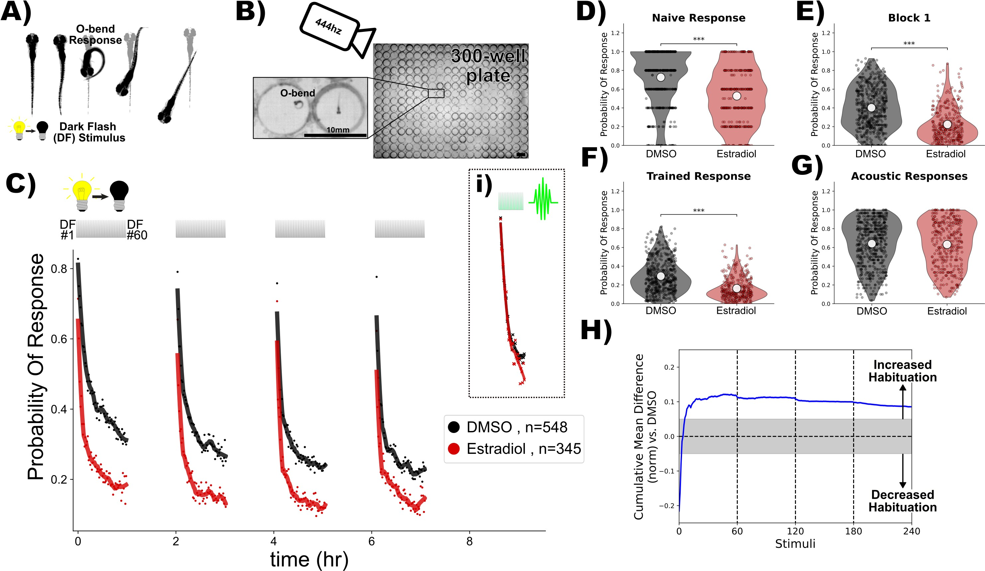

**Figure** **1. Estradiol increases habituation learning.**

1. In response to a dark ﬂash (DF), larval zebraﬁsh perform a large turning manoeuvre termed an "O-bend" response.
2. High-throughput setup for recording and quantifying responsiveness using a high-speed camera recording at 444hz observing larvae in 300-well plates. Scale bar = 10mm.
3. Treatment with estradiol (red) results in more rapid and profound decreases in the probability of response to DF stimuli during habituation training relative to DMSO vehicle controls (black). DF stimuli are delivered at 1-minute intervals, in 4 blocks of 60 stimuli, separated by 1hr of rest (from 0:00-7:00). 1.5 hours later a block of 30 vibration stimuli are delivered at 1-minute intervals (**i**). Each dot is the probability of response to one DF. Lines are smoothed in time with a Savitzky–Golay ﬁlter (window = 15 stimuli, order = 2). **D-G)** Distributions responsiveness for different epochs of the experiment. Each dot is the per-ﬁsh average of the epoch. Statistical signiﬁcance was calculated using

Mann-Whitney U test, *** = p < 0.001. **D)** the naive response to the ﬁrst 5 DF stimuli; **E)** the mean response to the remaining DF stimuli in the Block 1 (DFs 6:60); **F)** the trained response to the last 45 DFs in all four training blocks (DFs 16:60,76:120,136:180,196:240); **G)** the 30 vibration stimuli delivered with a tap from a solenoid on the 300-well plate platform.

**H)** Cumulative mean difference (CMD) plot quantifying relative habituation performance after estradiol treatment. These plots display the cumulative average differences in the mean response across larvae of the treatment group (estradiol) relative to the control group (DMSO). Difference from 0 reﬂect a divergence in the change in responsiveness

across the 240 DF stimuli in the 4 training blocks, with positive values reﬂecting increased habituation. The widths of the line is a bootstrapped 99.5% conﬁdence intervals. The gray boxed region reﬂects the expected non-signiﬁcant effect size [3].

Treatment groups are: Estradiol = 10µM estradiol treatment (n = 345 ﬁsh); DMSO = 0.1% DMSO vehicle controls (n = 548 ﬁsh)

# Results

## Estradiol increases visual habituation learning

In response to a sudden global darkening stimulus, which we refer to as a dark ﬂash (DF), larval zebraﬁsh execute an "O-bend" maneuver, characterized by a deep "O"-shaped bend and a high-amplitude turn (26, ***Figure 1***a). Habituation learning manifests as a progressive reduction in response to repeated stimuli, and this learning can be retained for seconds/minutes, or hours/days for short-, and long-term habituation, respectively [1]. We use high-speed cameras, machine-vision analysis, and 300-well plates to quantify habituation across large populations of larvae to identify molecular/genetic mechanisms of long-term habituation (***Figure 1***A,B, 3, 4). When stimulated with DFs repeated at 1-minute intervals in blocks of 60 stimuli, larval zebraﬁsh exhibit long-term habituation, reducing not only the probability of executing a response, but also modulating the latency and other kinematic aspects of the response [3].

Our previous small-molecule screening experiments identiﬁed multiple synthetic Estrogen Receptor ago- nists as positive modulators of DF habituation learning at 5-10 µM doses, including ethinyl estradiol, estradiol valerate, and hexestrol [4]. The major effect we observed was a stronger decrease in the probability of executing a O-bend response during the training/learning blocks. We have conﬁrmed and extended these results using estradiol, which is the major natural estrogen in vertebrates.

An acute dose of 10µM estradiol potently increases habituation learning, which is observable when the

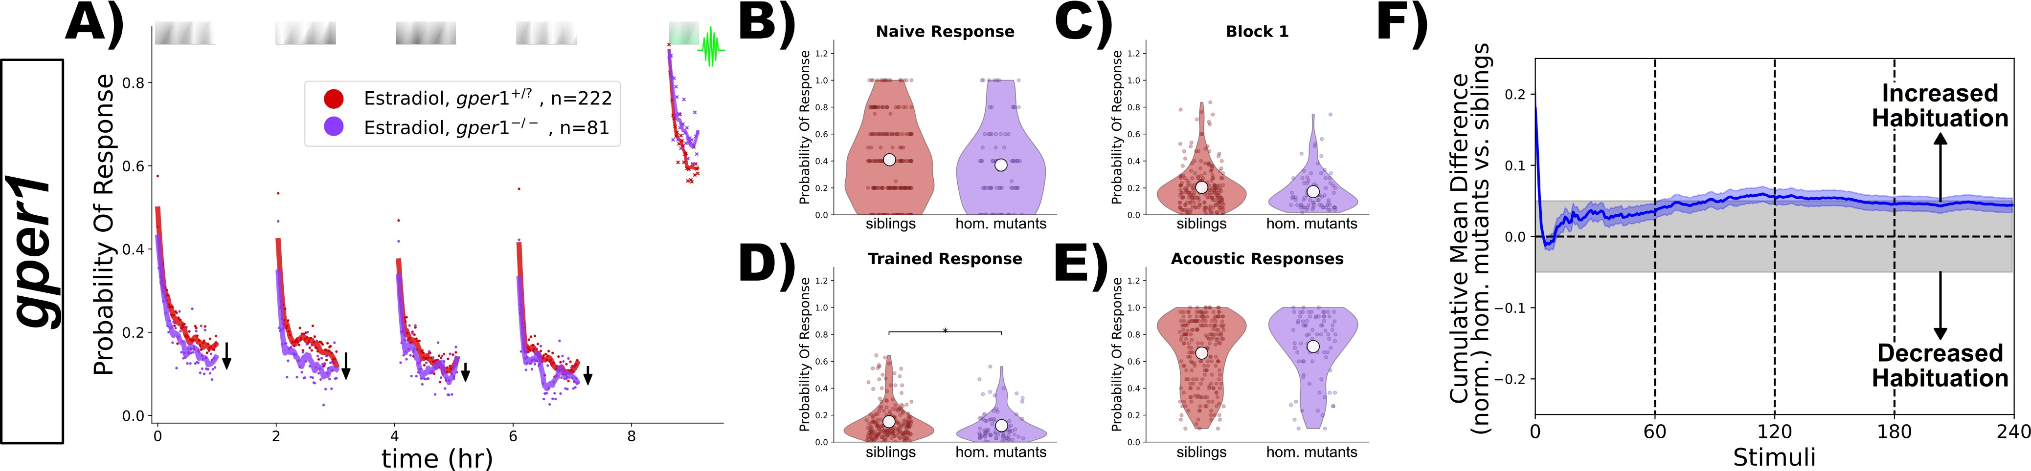

**Figure** **2. *gper1* mutants do not show habituation deﬁcits after treatment with estradiol.**

**A)** Homozygous *gper1(-/-)* mutants (n = 81 ﬁsh, purple) do not show impaired habituation relative to sibling controls (*gper1(+/-)* and *gper1(+/+)* , n = 222 ﬁsh, red). Rather, there is a slight suppression of responsiveness in the mutant group (arrows), indicating weakly increased habituation. Each dot is the probability of response to one stimulus. Lines are smoothed in time with a Savitzky–Golay ﬁlter (window = 15 stimuli, order = 2).

**B-E)** No signiﬁcant differences are observed in the responsiveness distributions for the naive response to the ﬁrst 5 DF stimuli (**B**), during the ﬁrst training block (**C**), or the

vibration response (**E**), while a subtle but statistically signiﬁcant decrease in responsiveness is observed in the trained response (**D**). Statistical signiﬁcance was calculated using Mann-Whitney U test, * = p < 0.05.

**F)** Cumulative mean difference (CMD) plot quantifying habituation performance of mutants relative to sibling controls, consistent with slightly increased habituation rate in mutant larvae.

response probability of the population of estradiol-treated larvae is compared with DMSO-treated vehicle controls (***Figure 1***C-H). Consistent with our previous experiments [4], there is a reduction in the naive responsiveness of the estradiol-treated larvae to the ﬁrst DF stimuli (***Figure 1***D), but the major effect is observed during the training phase (***Figure 1***C,E,F), as is revealed by the consistent positive deviation in the cumulative mean difference (CMD) plots that are normalized to the naive response level in order to quantify response suppression indicative of habituation performance (***Figure 1***H, 3). Importantly, the responsiveness of the larvae to vibration stimuli delivered after the DF stimulation (***Figure 1***Ci), which elicit c-bend escape responses [27], is indistinguishable from controls (***Figure 1***G). From this we conclude that estradiol does not affect global arousal levels but rather has speciﬁc effects on habituation learning.

## Gper1 is dispensable for estradiol-promoted habituation learning

The effects of estradiol that we have observed occur very rapidly – larvae are only pretreated with estradiol for ≈25min-1hr before the ﬁrst DF. This is the time necessary to set the apparatus and begin the experiment. Since ERα and ERβ are thought to primarily exert their effects via transcriptional alterations, this necessitates a delay in this aspect of their signaling. For this reason, we ﬁrst hypothesized that membrane-initiated signaling through Gper1 was the most likely mechanism.

To test this we used the *gper1uab102* mutant [24], and generated larvae from *gper1uab102* heterozygous or

homo/heterozygous crosses to generate clutches of larvae of mixed genotypes. Larvae were treated with estradiol during habituation, and were subsequently genotyped. We reasoned that if *gper1* is required for the effect of estradiol on habituation, mutants would be insensitive to estradiol and habituate signiﬁcantly less than sibling controls. Contrary to this hypothesis, we found that *gper1* mutants showed no deﬁcits in habituation (***Figure 2***). Remarkably, rather than observing the anticipated inhibition of habituation, *gper1* mutants appeared to habituate slightly more than controls, with the responsiveness level slightly but consistently below the sibling controls across stimuli (***Figure 2***A). This is further supported by a weak but statistically signiﬁcant decrease in the responsiveness of the larvae during the training period (***Figure 2***D), and a deviation towards positive values in the CMD plot (***Figure 2***F). From these experiments we conclude that Gper1 agonism does not promote habituation learning, but rather may act to suppress it.

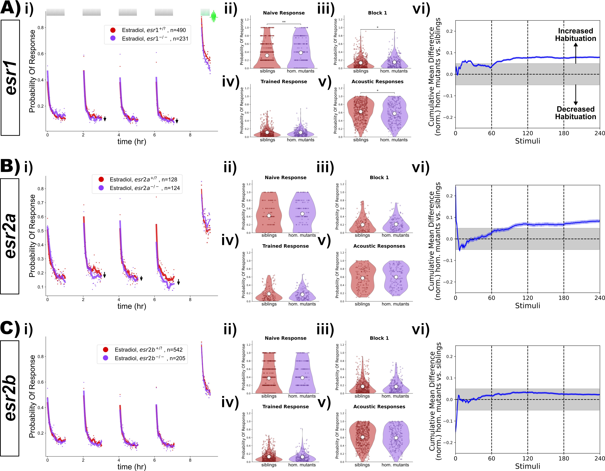

**Figure** **3. *esr1*, *esr2a* and *esr2a* mutants do not show habituation deﬁcits after treatment with estradiol.**

1. Homozygous *esr1(-/-)* mutants (n = 231 ﬁsh) do not show impaired habituation relative to sibling controls (*esr1(+/-)* and *esr1(+/+)* , n = 490 ﬁsh).
2. Homozygous *esr2a(-/-)* mutants (n = 214 ﬁsh) do not show impaired habituation relative to sibling controls (*esr2a(+/-)* and *esr2a(+/+)* , n = 128 ﬁsh).
3. Homozygous *esr2b(-/-)* mutants (n = 205 ﬁsh) do not show impaired habituation relative to sibling controls (*esr2b(+/-)* and *esr2b(+/+)* , n = 542 ﬁsh).

**i)-vi)** For each lettered section:

* 1. Responsiveness to stimuli comparing homozygous mutants to sibling controls (heterozygous or wild-type). Each dot is the probability of response to one stimulus. Lines are

smoothed in time with a Savitzky–Golay ﬁlter (window = 15 stimuli, order = 2). Suppression of responsiveness is indicated by arrows, potentially reﬂecting increased habituation.

**ii)-v)** Distributions responsiveness for different epochs of the experiment. Each dot is the per-ﬁsh average of the epoch. Statistical signiﬁcance was calculated using

Mann-Whitney U test, * = p < 0.05, ** = p < 0.01. **ii)** the naive response to the ﬁrst 5 DF stimuli; **iii)** the mean response to the remaining DF stimuli in the Block 1 (DFs 6:60); **iv)**

the trained response to the last 45 DFs in all four training blocks (DFs 16:60,76:120,136:180,196:240); **v)** the 30 vibration stimuli delivered with a tap from a solenoid on the 300-well plate platform.

1. Cumulative mean difference (CMD) plot quantifying habituation performance of mutants relative to sibling controls

## ERα and ERβ are dispensable for estradiol-promoted habituation learning

Since we found that *gper1* was unnecessary for the habituating-promoting effects of estradiol, we next focused on the three other ERs in the zebraﬁsh genome: *esr1*, *esr2a* and *esr2a*. While we initially prioritized Gper1 due to its rapid signaling properties that aligned with the rapid actions of estradiol on habituation, it is equally possible that the rapid membrane-initiated actions of ERα and/or ERβ could underlie these effects. Using the same strategy as for *gper1*, we analyzed previously established mutants (*esr2auab134*, *esr2auab134*, and *esr2buab127*), looking for a mutant with insensitivity to estradiol. However, we failed to identify any deﬁcits in habituation (***Figure 3***). To our surprise, we again found that both *esr1* and *esr2a* mutants showed subtle increases in habituation (***Figure 3***Avi,Bvi), similar in magnitude to what we had seen for *gper1* mutants (***Figure 2***F). From these data we conclude that none of the identiﬁed ERs are required for the effects of estradiol on promoting habituation. As for Gper1, ER1 and ER2a show a weak inhibitory effect on habituation, indicating that they also act to suppress habituation learning.

## ERα and ERβ are simultaneously dispensable for estradiol-promoted habituation learning

While our experiments demonstrated that *esr1*, *esr2a* and *esr2a* mutants remain sensitive to estradiol, it is plausible that they could act in a redundant fashion to mediate the effects of estradiol on habituation, perhaps via co-expression in a critical cell type, or via genetic compensation [28]. To test for this possibility, we generated combinations of mutants by crossing individual lines together (***Figure 4***). A likely scenario could be that the two ERβ paralogs, ER2a and ER2b, act redundantly. However, we found that double mutants for *esr2a;esr2b* did not show habituation deﬁcits (***Figure 4***A). Neither did we observe suppression of habituation in double mutants for *esr1;esr2a* (***Figure 4***B), or *esr1;esr2b* (***Figure 4***C). Finally, we tested triple mutants (*esr1;esr2a;esr2b*), but again failed to identify suppressions in habituation (***Figure 4***D).

We note that we did see a statistically "signiﬁcant" increase in DF responsiveness in the *esr1;esr2b* double mutants (***Figure 4***Cii-iv). This is attributable to a small increase in naive responsiveness, and did not result from habituation deﬁcits according to our normalized CMD analysis (***Figure 4***Cvi). Considering that we did not observe any increased responsiveness in the triple mutants (***Figure 4***D), we conclude that the observed increased responsiveness in the double mutants is likely a result of biological noise, that only rose to statistical "signiﬁcance" due to the very large number of larvae tested in our high-throughput experiments.

Consistent with the paradoxical effect of increased habituation in *esr1* and *esr2a* single mutants (***Figure 3***A,B), we again observed that double and triple mutants containing these genes also showed a slight increase in habituation (with the exception of the esr1;esr2b double mutants). This adds further support to the model in which ER1 and ER2b act to suppress learning in this context, rather than promote it.

## Gper1, ERα, and ERβ are simultaneously dispensable for estradiol-promoted habituation learning

While it is unclear to us how Gper1 might act redundantly with ERα/β, we nevertheless decided to test this possibility by combining the *gper1* and the *esr1*, *esr2a*, and *esr2b* mutations (***Figure 5***). As with the previous iterations of this experiment, we did not ﬁnd combinations of mutants with suppressed habituation (***Figure 5***). Consistent with our model of (*gper1*, *esr1* and *esr2a*) having inhibitory affects on learning, we again found that most of these combinations of mutants showed evidence of increased habituation (***Figure 5***i,vi). While the responsiveness distributions did not show signiﬁcant differences (***Figure 5***ii-iv), the normalized CMD plots consistently showed positive deviations, which reﬂect increased habituation (***Figure 5***vi).

Despite the fact that we analyzed the behaviour of 1152 larvae and successfully genotyping all 4 ER genes in 373 individuals (after >4600 genotyping PCRs), we were only able to identify a single quadruple mutant larva lacking all known ERs (***Figure 5***E). This is likely simply due to the limitations of combinatorial Mendelian

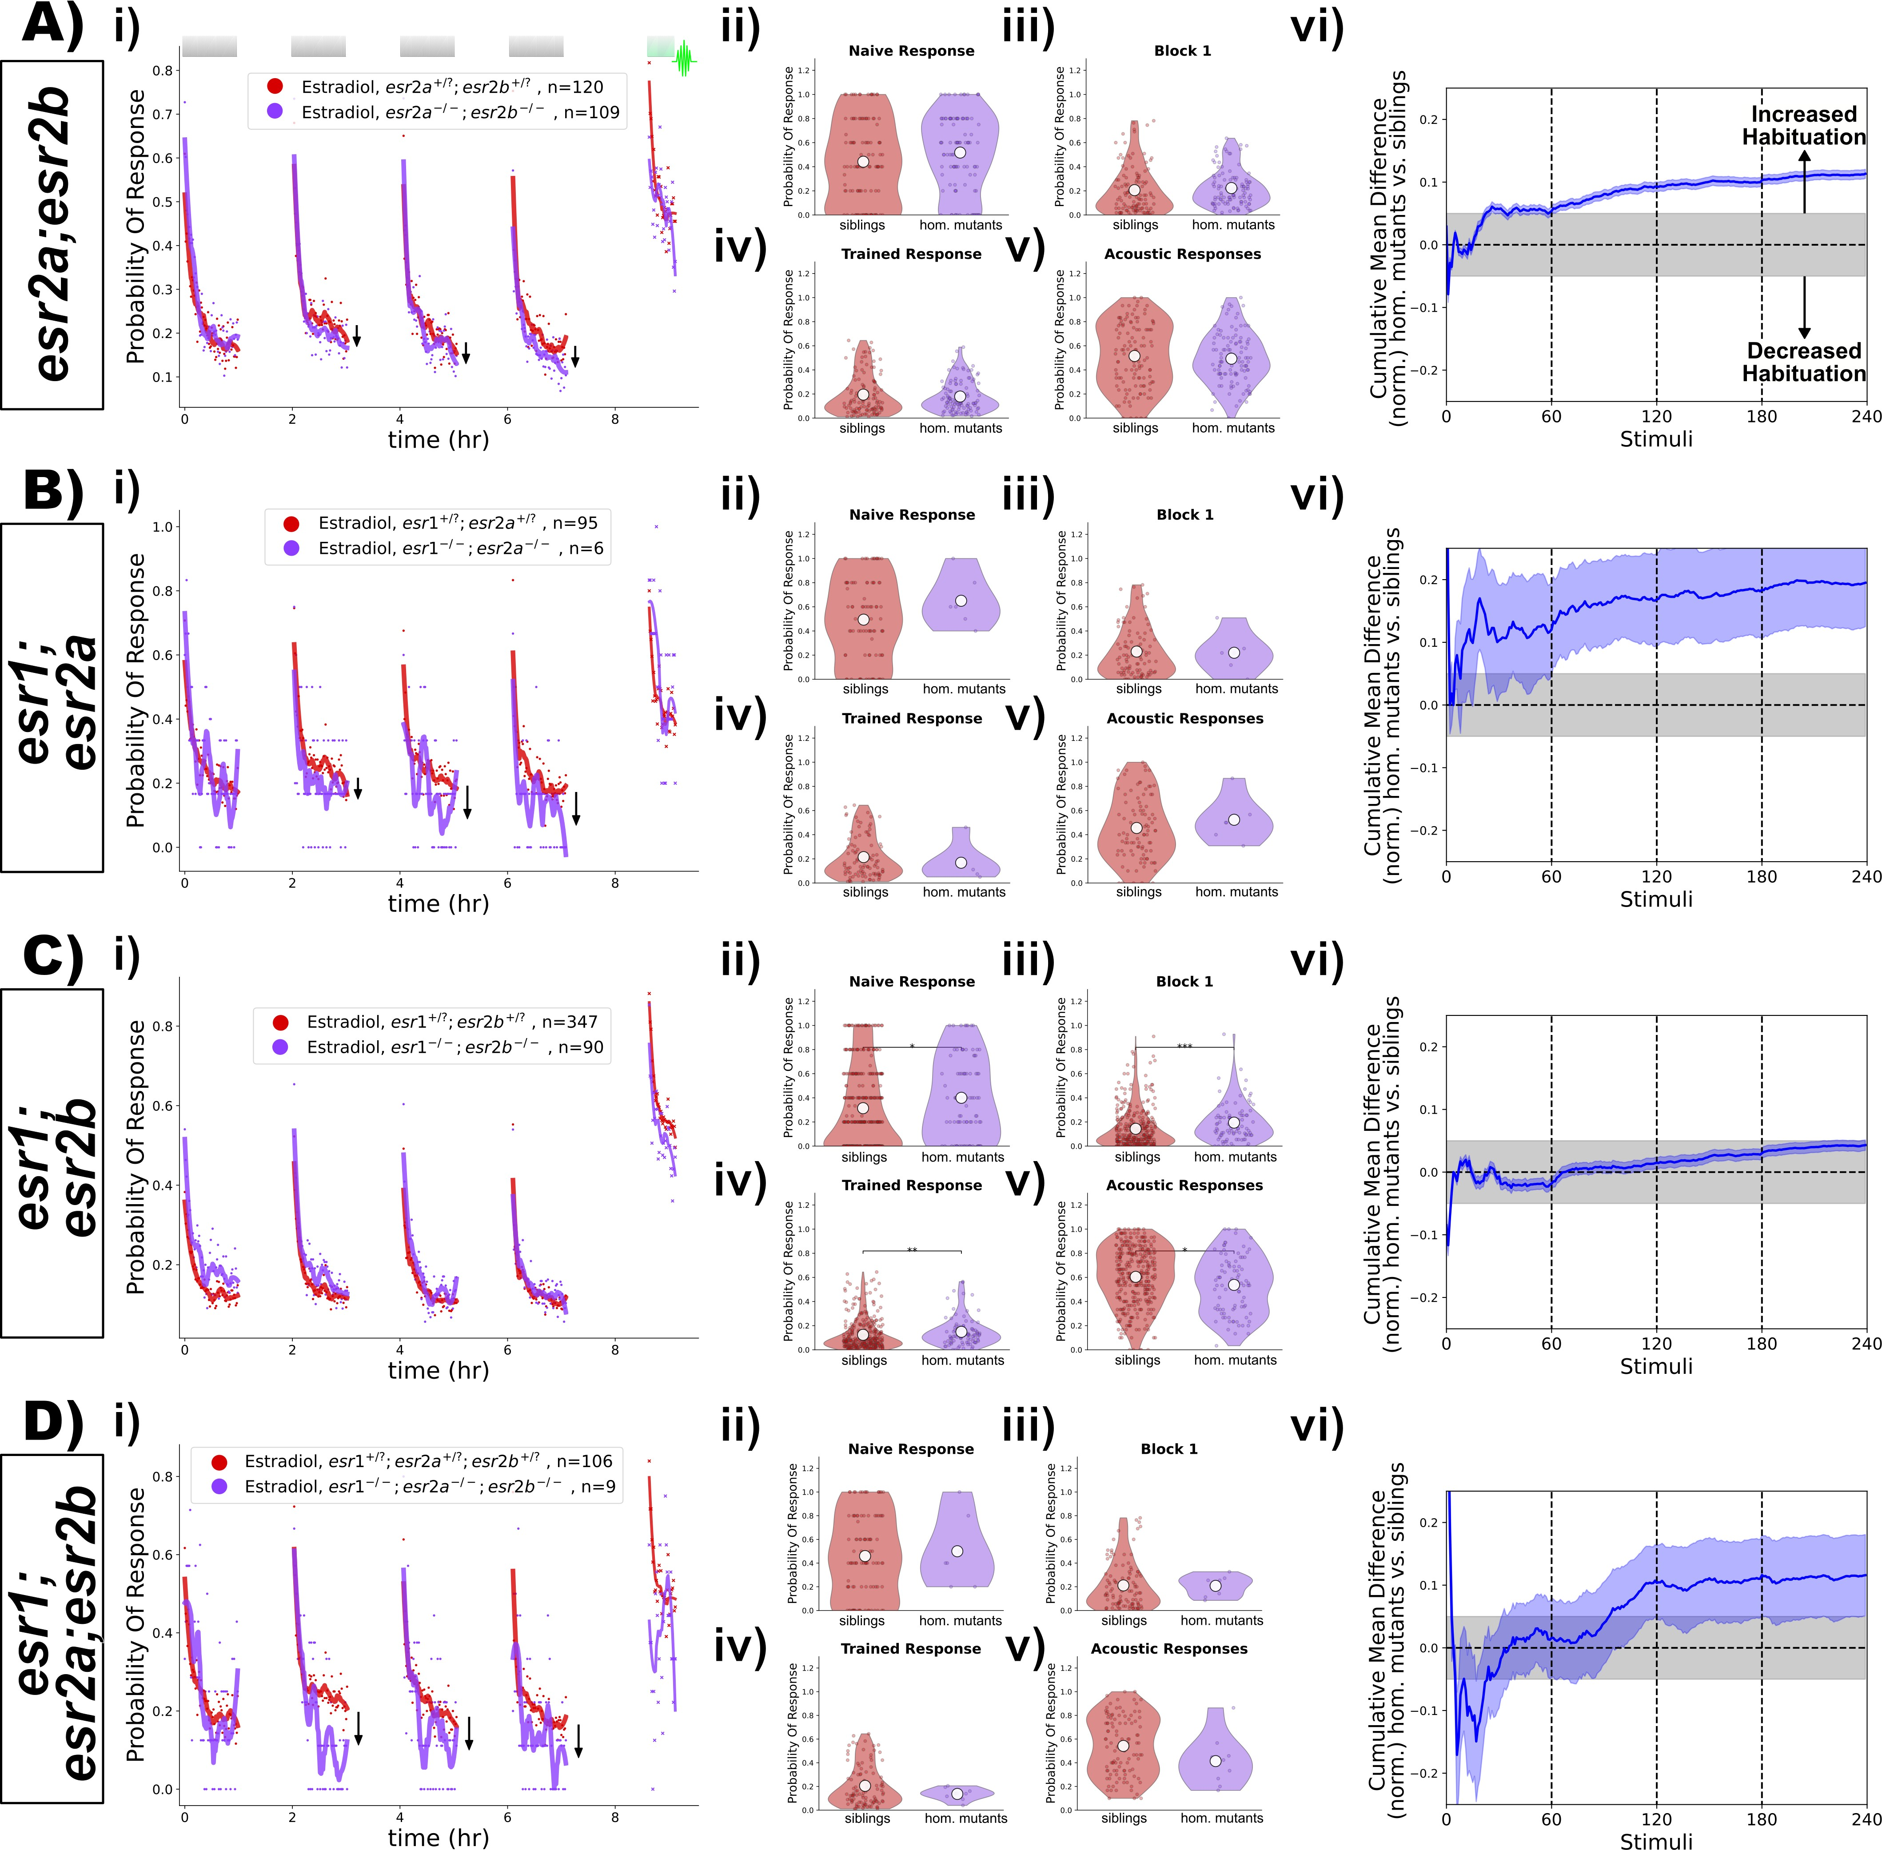

**Figure** **4. Double and triple mutant combinations of *esr1*, *esr2a* and *esr2a* do not show habituation deﬁcits after treatment with estradiol.**

* 1. Homozygous *esr2a(-/-) ;esr2b(-/-)* double mutants (n = 109 ﬁsh) do not show impaired habituation relative to double heterozygous or homozygous sibling controls (*(+/?);(+/?)* , n = 120 ﬁsh).
  2. Homozygous *esr1(-/-) ;esr2a(-/-)* double mutants (n = 6 ﬁsh) do not show impaired habituation relative to double heterozygous or homozygous sibling controls (*(+/?);(+/?)* , n = 95 ﬁsh).
  3. Homozygous *esr1(-/-) ;esr2b(-/-)* double mutants (n = 90 ﬁsh) do not show impaired habituation relative to double heterozygous or homozygous sibling controls (*(+/?);(+/?)* , n = 347 ﬁsh).
  4. Homozygous *esr1(-/-) ;esr2a(-/-) ;esr2b(-/-)* triple mutants (n = 9 ﬁsh) do not show impaired habituation relative to triple heterozygous or homozygous sibling controls (*(+/?);(+/?);(+/?)* , n = 106 ﬁsh).

**i)-vi)** For each lettered section:

* + 1. Responsiveness to stimuli comparing homozygous mutants to sibling controls (heterozygous or wild-type). Each dot is the probability of response to one stimulus. Lines are smoothed in time with a Savitzky–Golay ﬁlter (window = 15 stimuli, order = 2).

**ii)-v)** Distributions responsiveness for different epochs of the experiment. Each dot is the per-ﬁsh average of the epoch. Statistical signiﬁcance was calculated using

Mann-Whitney U test, * = p < 0.05, ** = p < 0.01. **ii)** the naive response to the ﬁrst 5 DF stimuli; **iii)** the mean response to the remaining DF stimuli in the Block 1 (DFs 6:60); **iv)**

the trained response to the last 45 DFs in all four training blocks (DFs 16:60,76:120,136:180,196:240); **v)** the 30 vibration stimuli delivered with a tap from a solenoid on the 300-well plate platform.

1. Cumulative mean difference (CMD) plot quantifying habituation performance of mutants relative to sibling controls.

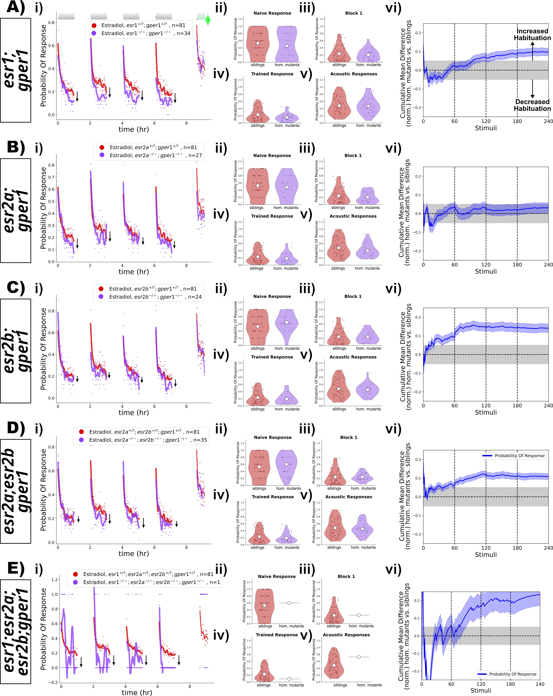

**Figure** **5. Double, triple and quadruple mutant combinations of *esr1*, *esr2a*, *esr2a*, and *gper1* do not show habituation deﬁcits after treatment with estradiol.**

* 1. Homozygous *esr1(-/-) ;gper1(-/-)* double mutants (n = 34 ﬁsh, purple) do not show impaired habituation relative to double heterozygous or homozygous sibling controls (n = 81 ﬁsh, red). **B)** Homozygous *esr2a(-/-) ;gper1(-/-)* double mutants (n = 27 ﬁsh, purple) do not show impaired habituation relative to double heterozygous or homozygous sibling

controls (n = 81 ﬁsh, red). **C)** Homozygous *esr2b(-/-) ;gper1(-/-)* double mutants (n = 24 ﬁsh, purple) do not show impaired habituation relative to double heterozygous or

homozygous sibling controls (n = 81 ﬁsh, red). **D)** Homozygous *esr2a(-/-) ;esr2b(-/-) ;gper1(-/-)* triple mutants (n = 35 ﬁsh, purple) do not show impaired habituation relative to

heterozygous or homozygous sibling controls (n = 81 ﬁsh, red). **E)** A single homozygous *esr1(-/-) ;esr2a(-/-) ;esr2b(-/-) ;gper1(-/-)* quadruple mutant (n = 1 ﬁsh, purple) does not appear to show impaired habituation relative to heterozygous or homozygous sibling controls (n = 81 ﬁsh, red).

**i)-vi)** For each lettered section: **i)** Responsiveness to stimuli comparing homozygous mutants to sibling controls (heterozygous or wild-type). Each dot is the probability of response to one stimulus. Lines are smoothed in time with a Savitzky–Golay ﬁlter (window = 15 stimuli, order = 2). **ii)-v)** Distributions responsiveness for different epochs of the experiment. Each dot is the per-ﬁsh average of the epoch. Statistical signiﬁcance was calculated using Mann-Whitney U test, * = p < 0.05, ** = p < 0.01. **ii)** the naive response to the ﬁrst 5 DF stimuli; **iii)** the mean response to the remaining DF stimuli in the Block 1 (DFs 6:60); **iv)** the trained response to the last 45 DFs in all four training blocks (DFs

16:60,76:120,136:180,196:240); **v)** the 30 vibration stimuli delivered with a tap from a solenoid on the 300-well plate platform. **vi)** Cumulative mean difference (CMD) plot

quantifying habituation performance of mutants relative to sibling controls. As mutant larvae were all derived from the same experiments, the sibling control data (red) is the same in **A-E)**.

inheritance, and the fact that *esr1* and *esr2a* are linked on chromosome 20. While it is dubious to conclude much from an n = 1 experiment, we ﬁnd it remarkable that this larva exhibits the strongest increased habituation of all of our experiments, with suppression of responses (***Figure 5***Ei), and strong positive deviation in the CMD plot (***Figure 5***Evi).

# Discussion

## The promotion of habituation learning by estradiol is mediated by an unidentiﬁed target

Our experiments indicate that Gper1, ER1, ER2a and ER2b do not mediate the positive effects of estradiol on habituation learning. As this is fundamentally a negative result, it is diﬃcult to conclusively demonstrate this beyond any doubt. One major caveat relates to the actual functional nature of the mutant alleles that we have used. These are all Cas9-generated small deletions resulting in frameshift mutations that lead to early stop codons, and are thus predicted null/knockout lines. Despite this genetic conﬁdence, it is always possible that residual activity could still remain, perhaps via alternate splicing or alternate start codons. This could be further complicated by genetic/transcriptional compensation, where frameshift alleles can lead to the upregulation of paralogs in some circumstances [28]. As with all negative results, it is not possible to rule out all possible alternative explanations. However, we recognize that this bias against publishing negative results is bad for science. Negative results from well-designed and executed experiments are of value for the community and making this knowledge public is our duty as responsible scientists [29].

While the possibility of "residual activity" in our mutants is a clear limitation of our approach, we argue that this alternative interpretation is very unlikely. The *esr1uab118* and *esr2buab127* alleles both exhibited a lack of estradiol responsiveness in other tissues [24], and *esr2buab127* mutants are female sterile/subfertile (D. Gorelick, personal communication), indicating a non-functional receptor. Similarly, *gper1uab102* mutants show a lack of estradiol responsiveness in heart rate modulation [24]. Interestingly this was only observed in maternal-zygotic

mutants. While it seems unlikely that suﬃcient maternal mRNA/protein for Gper1 could persist in 5dpf larvae, we can formally rule this out with our current datasets. The *esr2auab134* mutants have no previously published phenotype, and so we do not have an independent positive control for the nature of this allele. However, the best evidence we have against the "residual activity" hypothesis is that we actually found phenotypes in our assays for *esr1uab118*, *esr2auab134*, and *gper1uab102* mutants. These phenotypes are just of the unexpected sign, where mutants show increased habituation (discussed below).

## Candidate estradiol targets that could promote habituation learning

We have concluded that the lack of habituation deﬁcits in our mutants is due to the presence of an alternative receptor or pathway that mediates the learning-promoting effects of estradiol. In support of this model, a very recent study of estradiol-induced thrombosis came to the same conclusion, namely that an unidentiﬁed target mediates this process in larval zebraﬁsh [30]. Importantly, these thrombosis experiments were performed on different knockout alleles which are full genetic deletions, in which "residual activity" is not plausible. Together with our observations, these data suggest that a novel estradiol target exists which has multiple critical functions (at least in zebraﬁsh).

What might this unidentiﬁed target be? Various leads exist in the literature. One hypothesis posits the existence of an unidentiﬁed “Gq-mER” (Gq-coupled membrane estrogen receptor) [31, 32], and therefore estradiol may signal via additional GPCRs beyond Gper1. Another possibility is an interaction between estradiol and other membrane receptors, for example: the Voltage-Gated Sodium Channel Nav1.2 [33, 34], transient receptor potential (TRP) channels [35, 36], or various other ion channels [37]. The robust nature of our

"non-canonical" but clearly estradiol-dependent phenotype, combined with the high-throughput nature of our behavioural assays, could be an ideal assay for future screening efforts to attempt to identify novel estradiol target(s).

## Multiple Estrogen Receptors act to suppress habituation learning.

While we were surprised to ﬁnd that the classical ERs do not promote habituation, we were shocked to ﬁnd evidence of the opposite! We found that *esr1uab118*, *esr2auab134*, and *gper1uab102* mutants habituate more than their sibling controls (***Figure 1***, ***Figure 2***), consistent with a role for these ERs in inhibiting habituation. While effect sizes of these magnitudes border on those that are easily dismissible as "noise", they were not only observed in the single mutants experiments, but also in the double and triple mutant combinations of these alleles (***Figure 3***-***Figure 5***), providing good evidence that they are biologically meaningful effects. In fact, these multi-mutants generally exhibited larger effect sizes, consistent with an additive interaction.

Untangling the mechanisms of ER1-, ER2a- and Gper1-dependent suppression of habituation will require considerable further work. The additive interaction we observed genetically indicates that the ERs act cooperatively to suppress habituation learning. All three receptors are expressed in the larval zebraﬁsh brain [38, 24], but whether they are acting in the same or different cell types awaits characterization. The study of this inhibitory pathway may be challenging since it opposes the major learning-promoting effect of estradiol, and therefore may be more straightforward to study after the identiﬁcation and deletion of the estradiol target that promotes habituation. One attractive hypothesis relates to the observation that estradiol exposure increases aromatase expression in the zebraﬁsh brain [39, 40]. Since aromatase catalyzes the conversion of androgens into estrogens, ER mutants may have reduced levels of endogenous endogeous estrogens in the brain, which could lead to inhibited habituation. Future experiments aimed at manipulating the aromatase system in wild- type and ER mutant backgrounds could be used to test this hypothesis.

## Conclusion

What began as a straightforward study to identify the receptor(s) that mediate the habituation-promoting effects of estradiol has instead led us to a surprising and paradoxical result; canonical ERs do regulate habituation, but are suppressive and act in opposition to the habituation-promoting effects of estradiol. This ﬁts with the general theme of our studies of this habituation paradigm – we ﬁnd increasing complexity and contradiction within this "simple" learning process the deeper we look. This began with our detailed observations of behaviour, leading us to conclude that habituation results from a distributed plasticity process that adapts different aspects of behavior independently [3]. We believe that this property underlies our subsequent discoveries of pharmacological and genetic manipulations that can result in either speciﬁc changes in speciﬁc aspects of habituation (but not others), or even opposing effects, where a single manipulation can simultaneously increase and decrease habituation, depending on which component of behavior is measured [3, 4]. This complexity appears to be a fundamental property of habituation [41], and that the study of habituation will likely continue to surprise us, hopefully leading to unexpected insights into the nature of plasticity underlying learning and memory.

# Materials and Methods

## Animals

All experiments were performed on larval zebraﬁsh at 5 days post fertilization (dpf), raised at a density of ≈1 larvae/mL of E3 media supplemented with 0.02% HEPES pH 7.2. Larvae were raised in a 14:10h light/dark cycle at 28-29°C. Adult zebraﬁsh were housed, cared for, and bred at the following zebraﬁsh facilities: Plateau

de Recherche Expérimentale en Criblage In Vivo (PRECI, SFR Biosciences, Lyon) and the Animalerie Zebraﬁsh Rockefeller (AZR, SFR Santé Lyon Est, Lyon). Adult zebraﬁsh used to generate larvae were housed in accordance with regulations of the PRECI and AZR facilities, which are regulated by an internal animal wellbeing committee, and were approved by the animal welfare committee (comité d’éthique en expérimentation animale de la Région Rhône-Alpes: CECCAPP, Agreement # C693870602). Behaviour experiments were performed at the 5dpf stage, and are thus not subject to ethical review, but these procedures do not harm the larvae.

Mutant lines were obtained from D. Gorelick’s lab, and were of the following alleles:

*esr1uab118* is a 4bp deletion (ZDB-ALT-180420-2), yielding a predicted null frameshift/stop mutation, con- ﬁrmed by a lack of estradiol responsiveness in the heart as assayed by *Tg(5xERE:GFP)c262* expression [24].

*esr2auab134* is a 2bp deletion (ZDB-ALT-180420-3), yielding a predicted null frameshift/stop mutation [24]

*esr2buab127* is a 4bp deletion (ZDB-ALT-180420-4), yielding a predicted null frameshift/stop mutation, con- ﬁrmed by a lack of estradiol responsiveness in the liver as assayed by *Tg(5xERE:GFP)c262* expression [24].

*gper1uab102* is a 133bp deletion (ZDB-ALT-180420-1), yielding a predicted null frameshift/stop mutation, conﬁrmed by a lack of estradiol responsiveness in heart beating rate in maternal-zygotic mutants [24].

## Genotyping

*esr1uab118* was genotyped by PCR using the forward/reverse primer pair: GCTGGTCACCTTGAATGCTT/TGAGATGTGAGAGATGACTAGGA with a TM of 58°C yielding a 381 bp PCR product that was digested with the restriction enzyme ApeKI. The mutant product is not digested, and the wild type has two bands at 177 and 204 bp.

*esr2auab134* was genotypes by PCR using the forward/reverse primer pair:

CTTCAGCTGCAGGAAGTGGA/AAAGTCGGGCTTAGCGACTG with a TM of 58°C yielding a 236 bp PCR product that was digested with the restriction enzyme MboI. The mutant product is not digested, and the wild type has two bands at 180 and 56 bp

*esr2buab127* was genotypes by PCR using the forward/reverse primer pair:

TGGGCCTGAGATGCAGTAGT/GTGTGTGTCTTGGCCTCCTC with a TM of 60°C yielding a 431 bp PCR product that was digested with the restriction enzyme MbiI. The mutant product is digested into two bands of 150 and 281 bp and the wild type into 3 bands of 78, 150 and 198 bp.

*gper1uab102* was genotypes by PCR using the forward/reverse primer pair:

ATGGAGGAGCAGACTACCAATGTG/CCATCCAGATGAGGCTGCAA with a TM of 60°C yielding a mutant product of 372bp and a wild type product of 505 bp.

## Pharmacology

β-Estradiol (Sigma E2758, here referred to as "estradiol") was dissolved in dimethyl sulfoxide (DMSO) and stored at -20°C. Larvae were treated with estradiol immediately before the behavioural assay by pipetting 10-30uL of 10x solution directly into the behavioural wells, always with a ﬁnal concentration of 0.1% DMSO in E3.

## Habituation behaviour testing

Larval behavior was evaluated in 300-well plates using an updated version of the experimental setup previously described [3, 4]. Brieﬂy, 300-well plates were custom made using laser-cut acrylic sheets where each well measures 8 mm in diameter and 6 mm in depth, corresponding to an approximate water volume of 300 µL. These plates are suspended under a water bath held at 31°C, acting as a heated lid to minimize condensation and maintain a 29°C water temperature within each well. Behavioral recordings were made using a Mikrotron CXP-4 camera running at 444hz in conjunction with a Silicon Software frame grabber (Marathon ACX-QP, Basler), illuminated by IR LEDs (TSHF5410, digikey.com). Visual stimuli were presented using a rectangular array of 155 WS2813 RGB LEDs (144LED/M, aliexpress.com). For the DF stimulus, the LEDs were brieﬂy switched off (1 s),

then linearly returned to the original brightness over a 20 s interval. Vibration/Tap stimuli were administered using a solenoid (ROB-10391, Sparkfun). This behavioral paradigm was designed to be symmetrical: each 1 hr block of stimulation was followed by 1 hr of rest. During these rest periods, the camera was moves using a stepper motor controlled linear actuator (Hanpose HPV4, 500cm), which moved the camera between two plates, allowing us to screen up to 600 ﬁsh per experiment across two 300-well plates.

Control of the apparatus (RGB LEDs, solenoid, camera linear actuator) was implemented via a Raspberry Pi Pico microcontroller running CircuitPython (https://circuitpython.org/) (code : [code.py](https://github.com/owenrandlett/2025_HabEstrogen/tree/main/code/RigControl/PiPicro)) and custom Python software which handled the camera acquisition via the [Python wrapper of the Silicon Software Framegrabber](https://docs.baslerweb.com/frame-grabbers/python-wrapper) [SDK](https://docs.baslerweb.com/frame-grabbers/python-wrapper), triggered stimuli via the Raspberry Pi Pico, and tracked the head and tail coordinates of the larvae across the 300-wells at a baseline framerate of between 20-30hz (code : [Run_BigRig2.py](https://github.com/owenrandlett/2025_HabEstrogen/blob/main/code/RigControl/Run_BigRig2.py)). When a stimulus is delivered (DF or Vibration/Tap), a 1-second "Burst" video is recorded at the full frame rate as a Tiff ﬁle, from which the head and tail coordinates are subsequently tracked oﬄine (code : [TrackBurst_BigRig.py](https://github.com/owenrandlett/2025_HabEstrogen/blob/main/code/RigControl/TrackBurst_BigRig.py)). Larval zebraﬁsh tracking was done via background subtraction and morphological operations implemented using multiple open-source packages, including: OpenCV [42], scikit-image [43], NumPy [44], SciPy [45], and Numba [46].

## Data analysis

Data was analyzed in Python using custom written analysis scripts (code : [Analyze_EsrHab.py](https://github.com/owenrandlett/2025_HabEstrogen/blob/main/code/Analyze_EsrHab.py)). Responses to DFs and vibration/taps were identiﬁed as movement events that had a cumulative tail bend angle greater than 3 radian (O-bend)and 1 radian (C-bend), respectively. Data was analyzed using multiple open-source packages, including: NumPy [44], SciPy [45],Numba [46] and Pandas [47]. Data was plotted using Matplotlib [48] and seaborn [49]. Statistical "signiﬁcance" between the distributions was tested using the Mann-Whitney U test implemented in Scipy [45].

The cumulative difference plots to assess changes in habituation performance for the treatments were calculated as previously [3], where we ﬁrst calculated the average response across larvae for each group for each DF. This generated a mean vector for each group. These two vectors were normalized by dividing them by the naive response (mean response to the ﬁrst 5 DFs), and then the treatment group was subtracted from the control group, yielding a "mean difference" vector between stimulus and controls at each ﬂash. From this mean difference vector we calculated the cumulative mean distribution using Numpy’s ’nancumsum’ function divided by the number of stimuli experienced, or the index of the vector. To generate statistical conﬁdence in these distributions, we bootstrapped 2000 replicates, and calculated the 99.5% conﬁdence intervals using SciPy’s ’stats.norm.interval’ function. The assumption of this analysis is that if the two groups are habituating similarly, then the "mean difference" vector will exhibit a noise distribution centered at a mean of 0, and thus the cumulative mean distribution would remain near 0. Treatments that affect habituation will show strong increasing or decreasing cumulative mean distributions, reﬂecting increased or decreased habituation performance throughout training, respectively. We use an empirically deﬁned threshold of ±0*.*05 as the statistically meaningful effect size in this analysis, as is reﬂected in the shaded gray regions in the plots [3].

# Data Availability

Software and analysis code is available here: <https://github.com/owenrandlett/2025_HabEstrogen>. All datasets used in these analyses are available here: [HabEstrogen_Datasets](https://gofile.me/5sdws/xF6oQhqTA).

# Acknowledgments

We thank the Gorelick lab for sharing the ER-mutant zebraﬁsh lines, and for sharing genotyping protocols and expertise, and the Randlett group members for helpful advice regarding the manuscript and work. We are grateful to the staff of the PRECI and AZR zebraﬁsh facilities, including Laure Benard, Robert Renard, Annie Desenfant, Olivier Lohez, for the expert care provided to the zebraﬁsh. We also gratefully acknowledge the communities that develop and maintain the numerous open-source software packages we rely on, most of which could not be cited here.

# Funding

This work was supported by funding from the ATIP-Avenir program of the CNRS and Inserm, a Fondation Fyssen research grant, and the IDEX-Impulsion initiative of the University of Lyon.

# References

* + 1. Catharine H Rankin, Thomas Abrams, Robert J Barry, Seema Bhatnagar, David F Clayton, John Colombo, Gianluca Coppola, Mark A Geyer, David L Glanzman, Stephen Marsland, Frances K McSweeney, Donald A Wilson, Chun-Fang Wu, and Richard F Thompson. Habituation revisited: an updated and revised description of the behavioral characteristics of habituation. *Neurobiol. Learn. Mem.*, 92(2):135–138, September 2009.
    2. Marc A. Wolman, Roshan A. Jain, Laura Liss, and Michael Granato. Chemical modulation of memory formation in larval zebraﬁsh. *Proceedings of the National Academy of Sciences*, 108(37):15468–15473, September 2011.
    3. Owen Randlett, Martin Haesemeyer, Greg Forkin, Hannah Shoenhard, Alexander F Schier, Florian Engert, and Michael Granato. Distributed plasticity drives visual habituation learning in larval zebraﬁsh. *Curr. Biol.*, 29(8):1337–1345.e4, April 2019.
    4. Laurie Anne Lamiré, Martin Haesemeyer, Florian Engert, Michael Granato, and Owen Randlett. Functional and pharmacological analyses of visual habituation learning in larval zebraﬁsh. *Elife*, 12, December 2023.
    5. Stefan Nilsson and Jan-Ake Gustafsson. Biological role of estrogen and estrogen receptors. *Crit. Rev. Biochem. Mol. Biol.*, 37(1):1–28, 2002.
    6. Mohammad Naderi, Arash Salahinejad, Anoosha Attaran, Som Niyogi, and Douglas P Chivers. Rapid effects of estradiol and its receptor agonists on object recognition and object placement in adult male zebraﬁsh. *Behav. Brain Res.*, 384(112514):112514, April 2020.
    7. T Samuel Dillon, Laura C Fox, Crystal Han, and Christiane Linster. 17*𝛽*-estradiol enhances memory duration in the main olfactory bulb in CD-1 mice. *Behav. Neurosci.*, 127(6):923–931, December 2013.
    8. Oliver Rawashdeh, Nancy Hernandez de Borsetti, Gregg Roman, and Gregory M Cahill. Melatonin suppresses nighttime memory formation in zebraﬁsh. *Science*, 318(5853):1144–1146, November 2007.
    9. Antje Jilg, Philipp Bechstein, Anastasia Saade, Moritz Dick, Tian Xiao Li, Gianluca Tosini, Abdelhaq Rami, Ajmal Zemmar, and Jörg H Stehle. Melatonin modulates daytime-dependent synaptic plasticity and learning eﬃciency. *J. Pineal Res.*, 66(3):e12553, April 2019.
    10. Y El-Sherif, J Tesoriero, M V Hogan, and A Wieraszko. Melatonin regulates neuronal plasticity in the hippocampus. *J. Neurosci. Res.*, 72(4):454–460, May 2003.
    11. L A Barros, S Tuﬁk, and M L Andersen. The role of progesterone in memory: an overview of three decades. *Neurosci. Biobehav. Rev.*, 49:193–204, February 2015.
    12. H Kuhl. Pharmacology of estrogens and progestogens: inﬂuence of different routes of administration. *Climacteric*, 8 Suppl 1(sup1):3–63, August 2005.
    13. Cécile A Unger. Hormone therapy for transgender patients. *Transl. Androl. Urol.*, 5(6):877–884, December 2016.
    14. Szidónia Farkas, Adrienn Szabó, Anita Emőke Hegyi, Bibiána Török, Csilla Lea Fazekas, Dávid Ernszt, Tamás Kovács, and Dóra Zelena. Estradiol and estrogen-like alternative therapies in use: The importance of the selective and non-classical actions. *Biomedicines*, 10(4):861, April 2022.
    15. Karyn M Frick. Molecular mechanisms underlying the memory-enhancing effects of estradiol. *Horm. Behav.*, 74:4–18, August 2015.
    16. Javed Iqbal, Geng-Di Huang, Yan-Xue Xue, Mei Yang, and Xiao-Jian Jia. Role of estrogen in sex differences in memory, emotion and neuropsychiatric disorders. *Mol. Biol. Rep.*, 51(1):415, March 2024.
    17. Victoria N Luine. Estradiol and cognitive function: past, present and future. *Horm. Behav.*, 66(4):602–618, September 2014.
    18. C A Finney, A Shvetcov, R F Westbrook, N M Jones, and M J Morris. The role of hippocampal estradiol in synaptic plasticity and memory: A systematic review. *Front. Neuroendocrinol.*, 56(100818):100818, January 2020.
    19. Eric R Prossnitz and Matthias Barton. The G protein-coupled oestrogen receptor GPER in health and disease: an update.

*Nat. Rev. Endocrinol.*, 19(7):407–424, July 2023.

* + 1. Chetana M Revankar, Daniel F Cimino, Larry A Sklar, Jeffrey B Arterburn, and Eric R Prossnitz. A transmembrane intracellular estrogen receptor mediates rapid cell signaling. *Science*, 307(5715):1625–1630, March 2005.
    2. E J Filardo, J A Quinn, K I Bland, and A R Frackelton, Jr. Estrogen-induced activation of erk-1 and erk-2 requires the G protein-coupled receptor homolog, GPR30, and occurs via trans-activation of the epidermal growth factor receptor through release of HB-EGF. *Mol. Endocrinol.*, 14(10):1649–1660, October 2000.
    3. Aune Koitmäe, Yannik Karsten, Xiaoyu Li, Fabio Morellini, Gabriele M Rune, and Roland A Bender. GPER1 deﬁciency causes sex-speciﬁc dysregulation of hippocampal plasticity and cognitive function. *J. Endocrinol.*, 258(3), September 2023.
    4. Victor Briz, Yan Liu, Guoqi Zhu, Xiaoning Bi, and Michel Baudry. A novel form of synaptic plasticity in ﬁeld CA3 of hippocampus requires GPER1 activation and BDNF release. *J. Cell Biol.*, 210(7):1225–1237, September 2015.
    5. Shannon N Romano, Hailey E Edwards, Jaclyn Paige Souder, Kevin J Ryan, Xiangqin Cui, and Daniel A Gorelick. G protein-coupled estrogen receptor regulates embryonic heart rate in zebraﬁsh. *PLoS Genet.*, 13(10):e1007069, October 2017.
    6. Arnaud Menuet, Elisabeth Pellegrini, Isabelle Anglade, Odile Blaise, Vincent Laudet, Olivier Kah, and Farzad Pakdel. Molecular characterization of three estrogen receptor forms in zebraﬁsh: Binding characteristics, transactivation properties, and tissue distributions1. *Biol. Reprod.*, 66(6):1881–1892, June 2002.
    7. Harold A. Burgess and Michael Granato. Sensorimotor gating in larval zebraﬁsh. *The Journal of Neuroscience*, 27(18):4984–4994, May 2007.
    8. C B Kimmel, J Patterson, and R O Kimmel. The development and behavioral characteristics of the startle response in the zebra ﬁsh. *Dev. Psychobiol.*, 7(1):47–60, January 1974.
    9. Mohamed A El-Brolosy, Zacharias Kontarakis, Andrea Rossi, Carsten Kuenne, Stefan Günther, Nana Fukuda, Khrievono Kikhi, Giulia L M Boezio, Carter M Takacs, Shih-Lei Lai, Ryuichi Fukuda, Claudia Gerri, Antonio J Giraldez, and Didier Y R Stainier. Genetic compensation triggered by mutant mRNA degradation. *Nature*, 568(7751):193–197, April 2019.
    10. Ana Mlinarić, Martina Horvat, and Vesna Šupak Smolčić. Dealing with the positive publication bias: Why you should really publish your negative results. *Biochem. Med. (Zagreb)*, 27(3):030201, October 2017.
    11. Xinge Yu, Queena Y Zhao, Murat Yaman, Sylvia M Emly, Jacqueline K Lee, Hongyu Su, Allison C Ferguson, Chan- drasekaran Nagaswami, Saireudee Chaturantabut, Wolfram Goessling, John W Weisel, Richard J Auchus, and Jordan A Shavit. Hormone-induced thrombosis is mediated through non-canonical ﬁbrin(ogen) aggregation and a novel estrogen target in zebraﬁsh. *bioRxiv*, November 2024.
    12. Jian Qiu, Martha A Bosch, Sandra C Tobias, Andree Krust, Sharon M Graham, Stephanie J Murphy, Kenneth S Korach, Pierre Chambon, Thomas S Scanlan, Oline K Rønnekleiv, and Martin J Kelly. A g-protein-coupled estrogen receptor is involved in hypothalamic control of energy homeostasis. *J. Neurosci.*, 26(21):5649–5655, May 2006.
    13. Gwyndolin Vail and Troy A Roepke. Membrane-initiated estrogen signaling via gq-coupled GPCR in the central nervous system. *Steroids*, 142:77–83, February 2019.
    14. Altin Sula, David Hollingworth, Leo C T Ng, Megan Larmore, Paul G DeCaen, and B A Wallace. A tamoxifen receptor within a voltage-gated sodium channel. *Mol. Cell*, 81(6):1160–1169.e5, March 2021.
    15. Lindsey S Treviño and Daniel A Gorelick. The interface of nuclear and membrane steroid signaling. *Endocrinology*, 162(8), August 2021.
    16. Maja Payrits, Éva Sághy, Kata Csekő, Krisztina Pohóczky, Kata Bölcskei, Dávid Ernszt, Klaudia Barabás, János Szolcsányi, István M Ábrahám, Zsuzsanna Helyes, and Éva Szőke. Estradiol sensitizes the transient receptor potential vanilloid 1 receptor in pain responses. *Endocrinology*, 158(10):3249–3258, October 2017.
    17. Ricardo Ramírez-Barrantes, Karina Carvajal-Zamorano, Belen Rodriguez, Claudio Cordova, Carlo Lozano, Felipe Simon, Paula Díaz, Pablo Muñoz, Ivanny Marchant, Ramón Latorre, Karen Castillo, and Pablo Olivero. TRPV1-estradiol stereospeciﬁc relationship underlies cell survival in oxidative cell death. *Front. Physiol.*, 11:444, May 2020.
    18. Lee-Ming Kow and Donald W Pfaff. Rapid estrogen actions on ion channels: A survey in search for mechanisms. *Steroids*, 111:46–53, July 2016.
    19. Christine Thisse and Bernard Thisse. High-resolution in situ hybridization to whole-mount zebraﬁsh embryos. *Nat. Protoc.*, 3(1):59–69, 2008.
    20. Arnaud Menuet, Elisabeth Pellegrini, François Brion, Marie-Madeleine Gueguen, Isabelle Anglade, Farzad Pakdel, and Olivier Kah. Expression and estrogen-dependent regulation of the zebraﬁsh brain aromatase gene. *J. Comp. Neurol.*, 485(4):304–320, May 2005.
    21. Ruixin Hao, Maria Bondesson, Amar V Singh, Anne Riu, Catherine W McCollum, Thomas B Knudsen, Daniel A Gorelick, and Jan-Åke Gustafsson. Identiﬁcation of estrogen target genes during zebraﬁsh embryonic development through transcriptomic analysis. *PLoS One*, 8(11):e79020, November 2013.
    22. Troy A McDiarmid, Alex J Yu, and Catharine H Rankin. Habituation is more than learning to ignore: Multiple mechanisms serve to facilitate shifts in behavioral strategy. *Bioessays*, 41(9):e1900077, September 2019.
    23. Gary Bradski. The openCV library. *Dr. Dobb’s Journal: Software Tools for the Professional Programmer*, 25(11):120–123, 2000.
    24. Stefan Van der Walt, Johannes L Schönberger, Juan Nunez-Iglesias, François Boulogne, Joshua D Warner, Neil Yager, Emmanuelle Gouillart, and Tony Yu. scikit-image: image processing in python. *PeerJ*, 2:e453, 2014.
    25. Charles R Harris, K Jarrod Millman, Stéfan J van der Walt, Ralf Gommers, Pauli Virtanen, David Cournapeau, Eric Wieser, Julian Taylor, Sebastian Berg, Nathaniel J Smith, Robert Kern, Matti Picus, Stephan Hoyer, Marten H van Kerkwijk, Matthew Brett, Allan Haldane, Jaime Fernández Del Río, Mark Wiebe, Pearu Peterson, Pierre Gérard-Marchant, Kevin Sheppard, Tyler Reddy, Warren Weckesser, Hameer Abbasi, Christoph Gohlke, and Travis E Oliphant. Array programming with NumPy. *Nature*, 585(7825):357–362, September 2020.
    26. Pauli Virtanen, Ralf Gommers, Travis E Oliphant, Matt Haberland, Tyler Reddy, David Cournapeau, Evgeni Burovski, Pearu Peterson, Warren Weckesser, Jonathan Bright, Stéfan J van der Walt, Matthew Brett, Joshua Wilson, K Jarrod Millman, Nikolay Mayorov, Andrew R J Nelson, Eric Jones, Robert Kern, Eric Larson, C J Carey, İlhan Polat, Yu Feng, Eric W Moore, Jake VanderPlas, Denis Laxalde, Josef Perktold, Robert Cimrman, Ian Henriksen, E A Quintero, Charles R Harris, Anne M Archibald, Antônio H Ribeiro, Fabian Pedregosa, Paul van Mulbregt, and SciPy 1.0 Contributors. SciPy 1.0: fundamental algorithms for scientiﬁc computing in python. *Nat. Methods*, 17(3):261–272, March 2020.
    27. Siu Kwan Lam, Antoine Pitrou, and Stanley Seibert. Numba: A llvm-based python jit compiler. In *Proceedings of the Second Workshop on the LLVM Compiler Infrastructure in HPC*, pages 1–6, 2015.
    28. Wes McKinney. Data Structures for Statistical Computing in Python. In Stéfan van der Walt and Jarrod Millman, editors,

*Proceedings of the 9th Python in Science Conference*, pages 56 – 61, 2010.

* + 1. J. D. Hunter. Matplotlib: A 2d graphics environment. *Computing in Science & Engineering*, 9(3):90–95, 2007.
    2. Michael Waskom. seaborn: statistical data visualization. *J. Open Source Softw.*, 6(60):3021, April 2021.